BUDGETING PACKET
Use this packet to survive the month. On the 1st page you have a salary breakdown. Use this to figure out the amount of money you and your roommate will have to use monthly. On the 2nd page you will find rent and utility pricing as well as a blank table to add any extra expenses. Both of these pages will help you figure out if you can survive the month using the Constructing a Budget WS on pages 3 &4. You can add information to this word document or print out a copy to use.
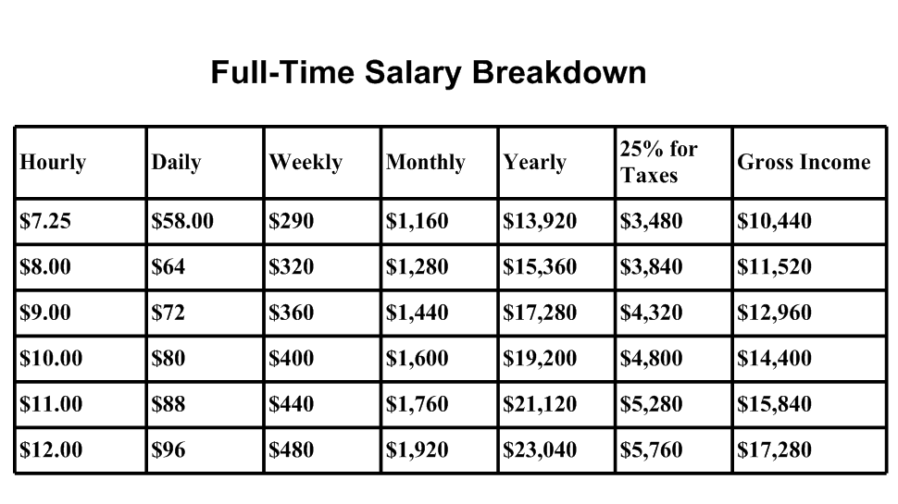

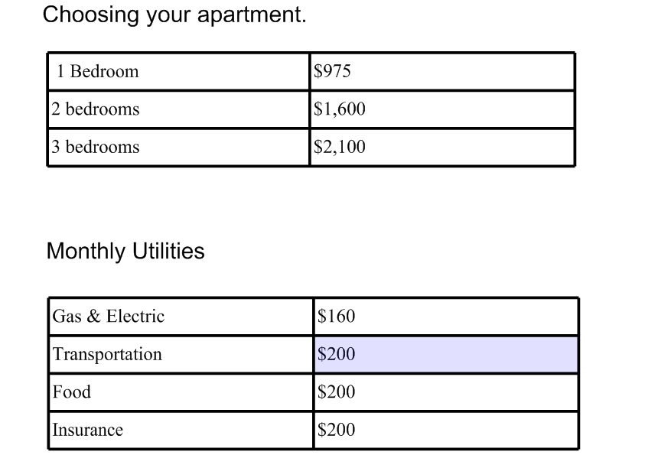

Extra Monthly Expenses
Use the links provided on the website to view cable, phone, internet and other plans that you may want to add to your budget.
Monthly Expense | Monthly Fee
Cell Phone
Cable
Internet
Home Phone
Other

Constructing a Budget

DIRECTIONS: Use this packet and the internet to answer the following questions. If you run out of money before number 5 below, start over and be more careful with your money!

- You and a friend want to share an apartment. Each roommate will be given a job and salary for a high school graduate. List name of the job that you think will match your salary and the amount you will be making monthly. (Use page 1 to help you.)

Roommate Name:  Job Title:  Monthly Income: $ | Roommate Name:  Job Title:  Monthly Income: $

Total income for two roommates

$_______________________ monthly

- Using the total monthly income above as a guide, find an apartment you can afford. Use the listed rent options to choose a rent that you and your partner can afford. List number of bedrooms and monthly rent below.

Bedroom(s):
Rent: $
Amount of money left over: $

- Water, electricity and gas cost money. Estimate their cost as 10 percent of the rent money.

Cost of Utilities per month: $
Amount of money left over: $

- Factor in costs for things such as a Cell Phone, Cable TV, Internet and possibly a Home Phone.

Cost of Extra Utilities per month:
Amount of money left over: $

- How much will you allow yourselves to spend each month?

Expected Spending (movies, shopping, eating out, etc.): $
Amount of money left over: $

- How much do you plan on spending on food?
Food per month: $
Amount of money left over: $

- You will have one car for you and your roommate(s). How much will you spend on insurance and fuel a month?

Insurance: $
Fuel: $
Amount of money left over: $

- Are there any other expenses that you and your roommate have? If so, list below?

Other Expenses:
Type:
Amount: $
Amount of money left over: $

- Do you have any money left over for entertainment? How much?

Entertainment: $
Amount of money left over: $

