Poster Ad Requirements

Directions: Save a copy of this document into your folder. Fill out the area below before beginning your project. Use the highlight tool to select the category and special effect.

Name: |  | Date:
*Choose a poster category. (Highlight the topic and fill in the name.)

- Movie
Name of movie:

- Product
Name of product:

- Public Announcement
Name of announcement:

- Game
Name of game:

- Event
Name of event:

*Highlight one or more special effect(s) you would like to use.
Perspective | Adding & Removing Color |  | Out of Bounds
 | 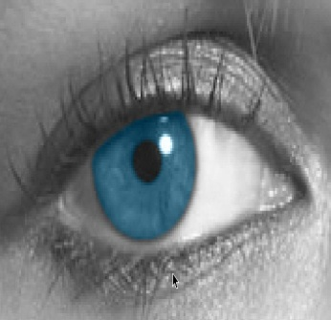 |  | 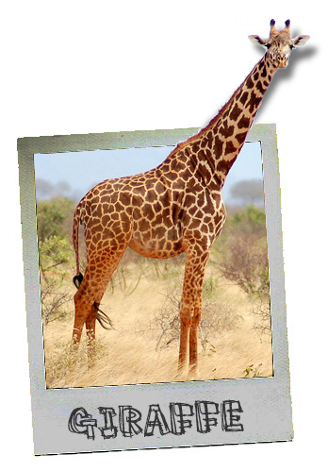
*Your poster should include:
- A poster category.  - At least one special effect.  - More than 3 layers. | - A title and supporting text, images that relate to the event, product or announcement.  - Complete a 1st, 2nd, and Final Draft.

