Why Do I Need to Think Before I Post?

Once something is posted online, it is often impossible to erase it. Even if you delete the original post, what you posted may have already been retweeted, screenshotted, or shared by someone else. You do not have the power to delete these new posts that contain your original content.

Because items we share can never really be deleted, they become part of our digital footprint -- what others see when they search for us online. It is our responsibility to post content that will help us build a positive digital footprint. When future schools, employers, or friends search for you, you want them to see the best version of you. If you do not think before you post, all they might are your mistakes and regrets.

Questions to Ask Yourself Before You Post

- Is this something I would want my mom to see? -- Remember, that even if you share something on a private account with strong privacy settings, your friends or followers can reshare your content on their social media accounts, making your original post available for the world to see. If you wouldn’t want family or future bosses to see it, it is safer to not post it in the first place.

- Is it kind? -- While humorous, sarcastic posts can go viral and get you lots of online attention, it can be very easy for these types of posts to be misinterpreted. Something you intended as a joke could be taken literally and offend hundreds, thousands, or millions of people.

- Is it true? -- Posting misinformation online weakens your credibility and depending on the situation and what is said, could open you up lawsuits.

- Is posting this going to cause drama? -- Maybe it is a picture of a friend that you find funny, but they might find embarrassing. Maybe you are bragging about getting away with something you should not have done (skipping class, sneaking out of the house, etc.). If your post could cause drama for you or anyone else, just keep it to yourself!
For each of the posts below, decide whether or not you think the poster was SAFE to share what they did or if they got SACKED from their job for sharing too much. Explain your choice.

Post | Safe or Sacked? | Explain why you think so
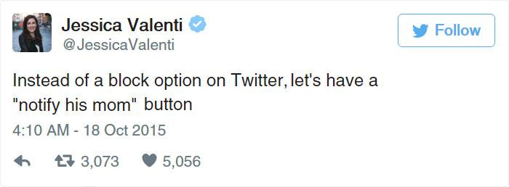
Post | Safe or Sacked? | Explain why you think so
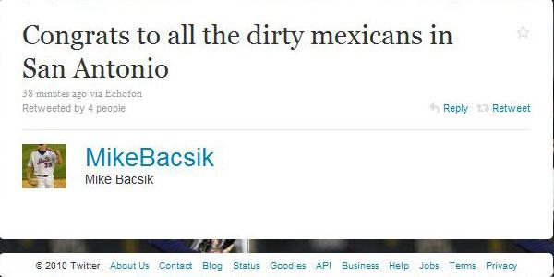
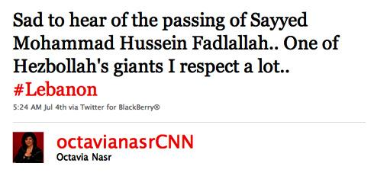
Post | Safe or Sacked? | Explain why you think so
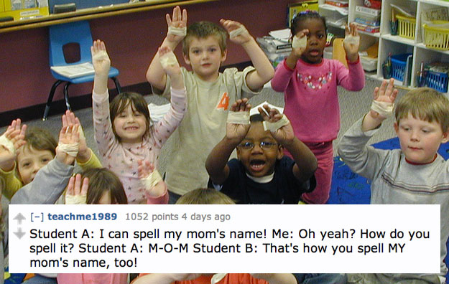
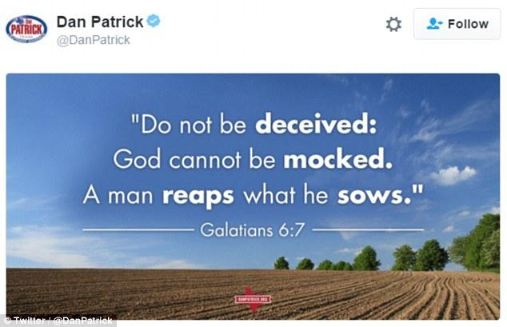
Post | Safe or Sacked? | Explain why you think so
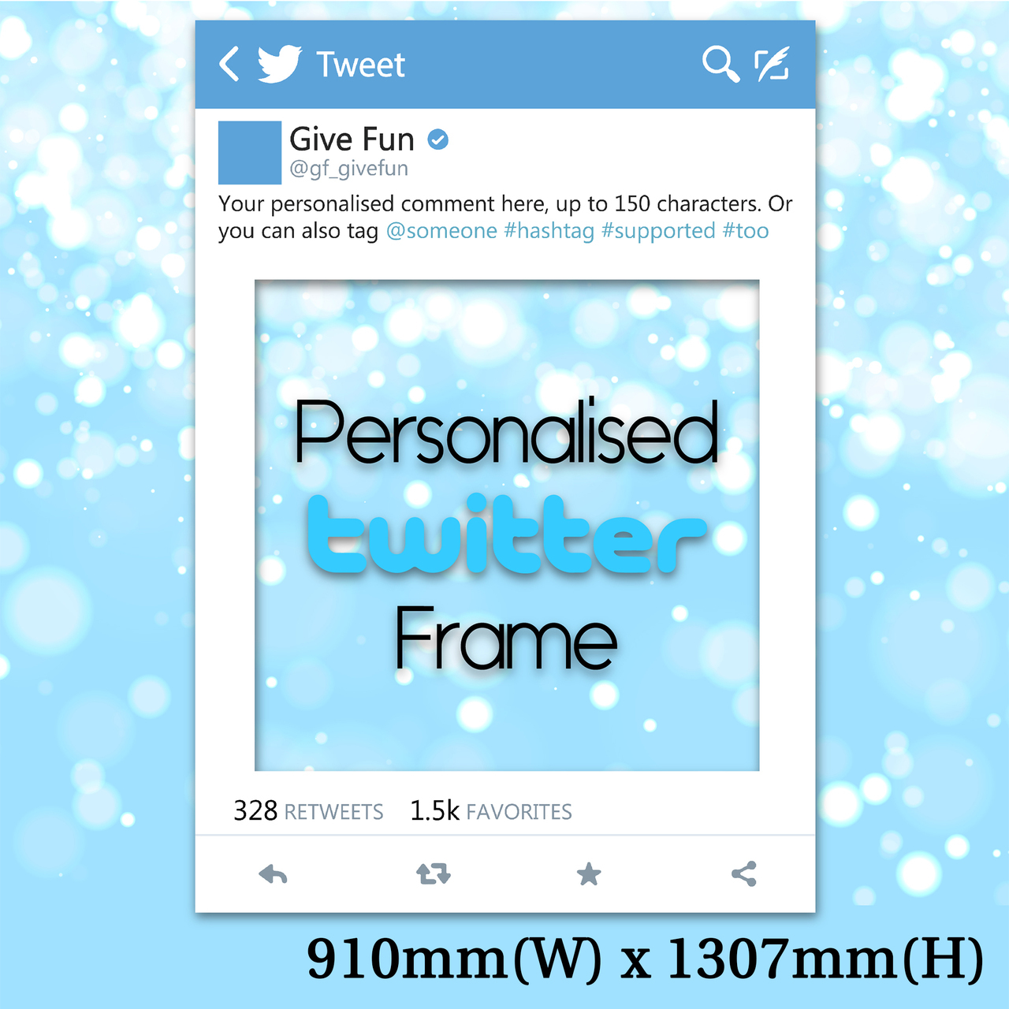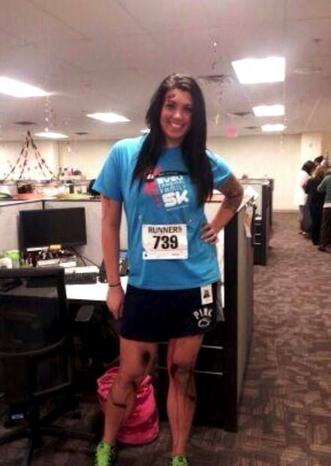
Alicia Lynch went to work dressed as a Boston Marathon bombing victim for Halloween.

