Designing a School T-Shirt
- Select Budget Short Sleeve by clicking on the red t-shirt.
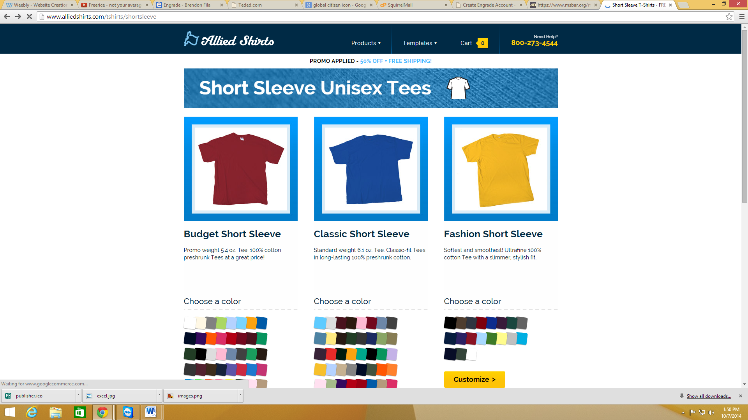
- Select a shirt color.
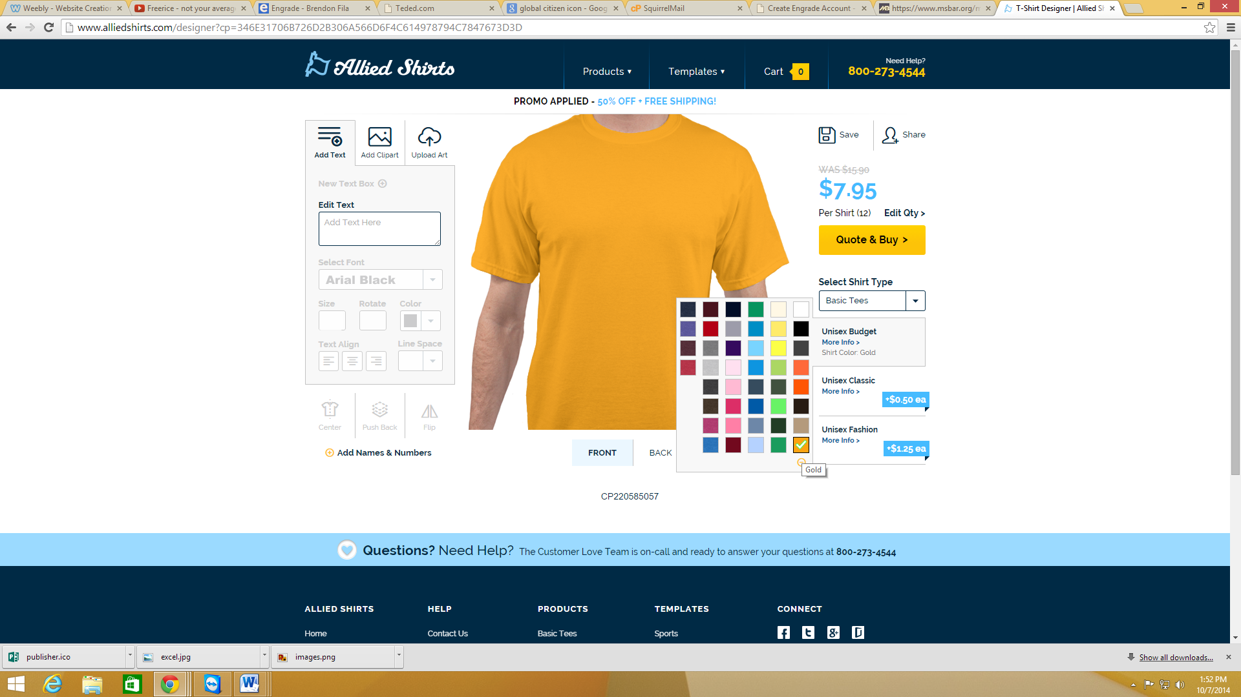

- Add text to the t-shirt.
NOTE: Add your name in a small corner of the shirt. This is only being used to grade the project.

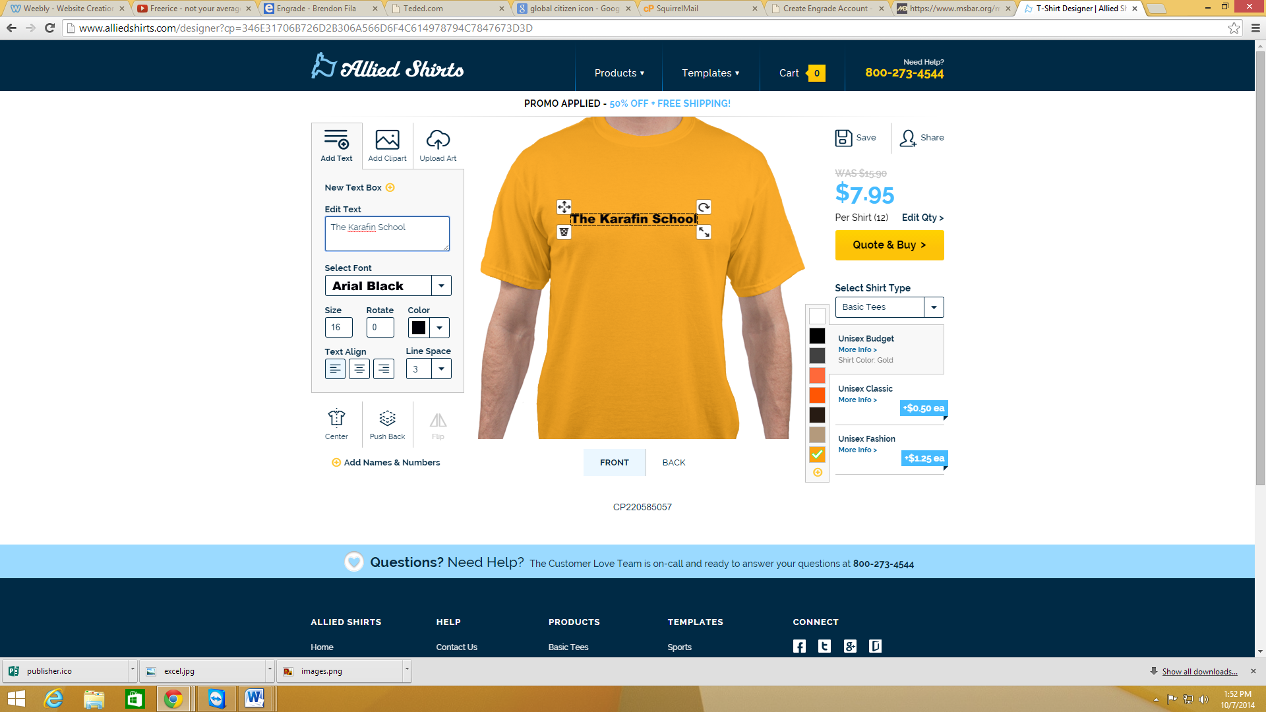
- Add Clip Art
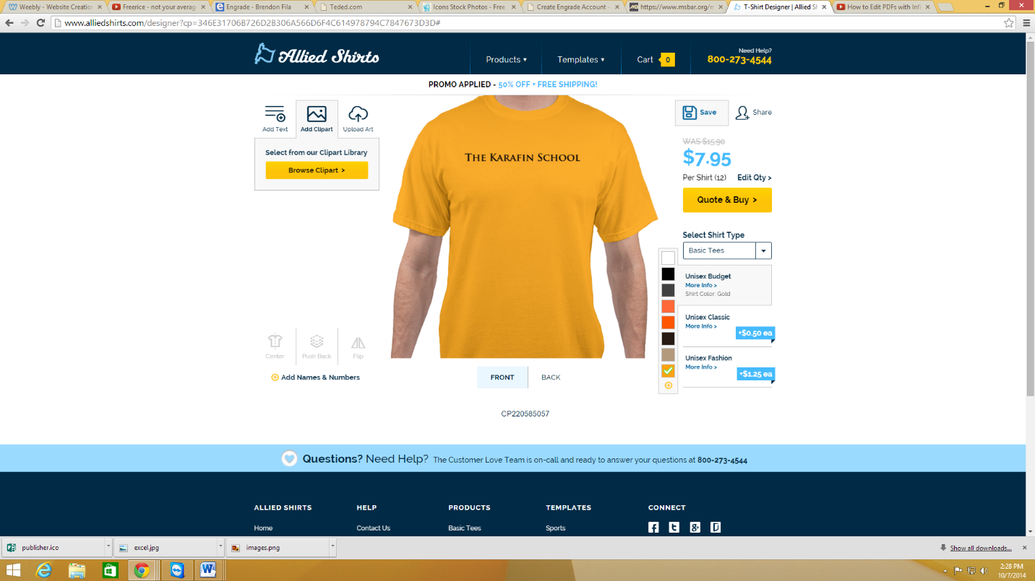
- Click Save.
- Enter lukm@karafinschool.com in the email box and click Save. This will submit you t-shirt design to the teacher.
Want to keep a copy of you design? Repeat step 5 and 6 with your own e-mail address and a copy will be sent to you.
